**CSC 1101 – Problem Solving and Programming Laboratory**

**Lab 18 – rory lange**

**25 points – Due April 5, 11pm**

**a)** Save this document with your name and the lab assignment number somewhere in the file name.

**b)** Type/paste your answers into the document.

**c)** Submit the following documents to the Canvas assignment link where you downloaded this document:

✓ This document.

✓ Your .cpp files renamed to .txt.

Submit the documents separately, not as one .zip file.

You've been hired by *Happy Hoopsters* to write a C++ console application that tracks the scores of a four-quarter basketball game. Declare two integer arrays of size four to hold the scores by quarter for each team (no overtime allowed in this league). Attempt to open an output file. If it doesn't open, print an error message and end the application. If it does open, initialize the two arrays using function **resetScores** (described below). Prompt the user for the points scored in each quarter by each team. Use any two team nicknames. Store the scores in the two arrays. Then print the scores after each quarter by calling function **printScores** (described below). After the scores for the game have been entered, print the final score. Also write the final score to the output file. Continue to prompt the user for game scores until they enter the sentinel value of 'n'. Define global constants for the array size, output file name, and column widths. Create and use the following functions:

**void resetScores(int scores[])**

This void function loops through an array and sets all its values to zero.

**int teamScore(int scores[], int quarter)**

This value function loops through an array and adds all the scores of the quarters played so far. Parameter **quarter** ranges from 1 to 4. This means, for example, if quarter is 2, then the first two scores in the array are added and returned.

**void printScores(int team1[], int team2[], int quarter)**

This void function loops through each array, prints the scores of the quarters played so far, and then prints the team score by calling function **teamScore**. Parameter **quarter** ranges from 1 to 4. This means, for example, if quarter is 3, then the first three scores in the array are printed and tallied by function **teamScore**. Use formatted output manipulators (setw, left/right) to print the team name, quarter scores, and team score in one row. The output should look like this:

Welcome to Happy Hoopsters

--------------------------

Enter another game (y or n)? y

Game 1

--------------------------------

Game 1, quarter 1

Enter Warriors score: 12

Enter Lakers score: 8

Score after quarter 1

Warriors 12 12

Lakers 8 8

Game 1, quarter 2

Enter Warriors score: 17

Enter Lakers score: 21

Score after quarter 2

Warriors 12 17 29

Lakers 8 21 29

Game 1, quarter 3

Enter Warriors score: 24

Enter Lakers score: 7

Score after quarter 3

Warriors 12 17 24 53

Lakers 8 21 7 36

Game 1, quarter 4

Enter Warriors score: 19

Enter Lakers score: 23

Score after quarter 4

Warriors 12 17 24 19 72

Lakers 8 21 7 23 59

Game 1 final score: Warriors 72, Lakers 59

Enter another game (y or n)? n

1 games(s) written to file 'Scores.txt'.

End of Happy Hoopsters

Loop the program three times with scores different from the

sample input for the final runs pasted below.

//==========================================================

//

// Title:      Happy Hoopsters

// Course:     CSC 1101

// Lab Number: 18-1

// Author:     rory lange

// Date:       4/1/21

// Description:

//   This C++ console application tracks scoring @@@

//

//==========================================================

#include <cstdlib>  // For several general-purpose functions

#include <fstream>  // For file handling

#include <iomanip>  // For formatted output

#include <iostream>  // For cin, cout, and system

#include <string>  // For string data type

using namespace std;  // So "std::cout" may be abbreviated to "cout"

//global variables

string team1 = "Celtics";

string team2 = "Heat";

const int W = 10;

const int W1 = 7;

int total1;

int total2;

const string fileName = "scores.txt";

const int ArrSize = 4;

//-------------------------------------------------------------------------------------------------------

void resetScores(int scores[]) {

    for (int i = 0; i < ArrSize; i++) {

        scores[i] = 0;

        //cout << scores[i] << endl;

    }

}

//-------------------------------------------------------------------------------------------------------

void printScores(int team1[], int team2[], int quarter) {

    total1 = 0;

    total2 = 0;

    cout << "Score after quarter " << quarter << endl;

    cout << left << setw(W) << "Celtics";

    for (int i = 0; i < quarter; i++) {

       cout << right << setw(W1) << team1[i];

       total1 = total1 + team1[i];

    }

    cout << right << setw(W) << total1;

    cout << endl << left << setw(W) << "Heat";

    for (int i = 0; i < quarter; i++) {

       cout << right << setw(W1) << team2[i];

       total2 = total2 + team2[i];

    }

    cout << right << setw(W) << total2;

    cout << endl;

}

//-------------------------------------------------------------------------------------------------------

int main() {

    //declare variables

    int team1[ArrSize];

    int team2[ArrSize];

    ofstream outputFile;

    string n;

    int game = 0;

    outputFile.open(fileName);

    //header

    cout << "Welcome to happy hoopsters" << endl;

    cout << "--------------------------" << endl << endl;

    if (!outputFile.is_open())

        cout << "Error opening file" << endl;

    else {

        //sentinel

        while (n != "n") {

            game++;

            resetScores(team1);

            resetScores(team2);

            for (int i = 1; i <= 4; i++) {

                cout << "Game " << game << ", quarter " << i << endl;

                cout << "Enter Celtics score: ";

                cin >> team1[i-1];

                cout << "Enter Heat score: ";

                cin >> team2[i-1];

                printScores(team1, team2, i);

                cout << endl;

            }

            cout << "Game " << game << " final score: " << "Celtics " << total1

                << ", Lakers " << total2 << endl << endl;

            outputFile << "Game " << game << " final score: " << "Celtics " << total1

                << ", Lakers " << total2 << endl;

            cout << "Enter another game (y or n)? ";

            cin >> n;

        }

        cout << game << " games written to file 'scores.txt'" << endl;

        cout << "end of Happy Hoopsters" << endl;

    }

}

**If possible, format your code like this:**

**Font “Courier New”**

**Font size “9”s**

**Bold**

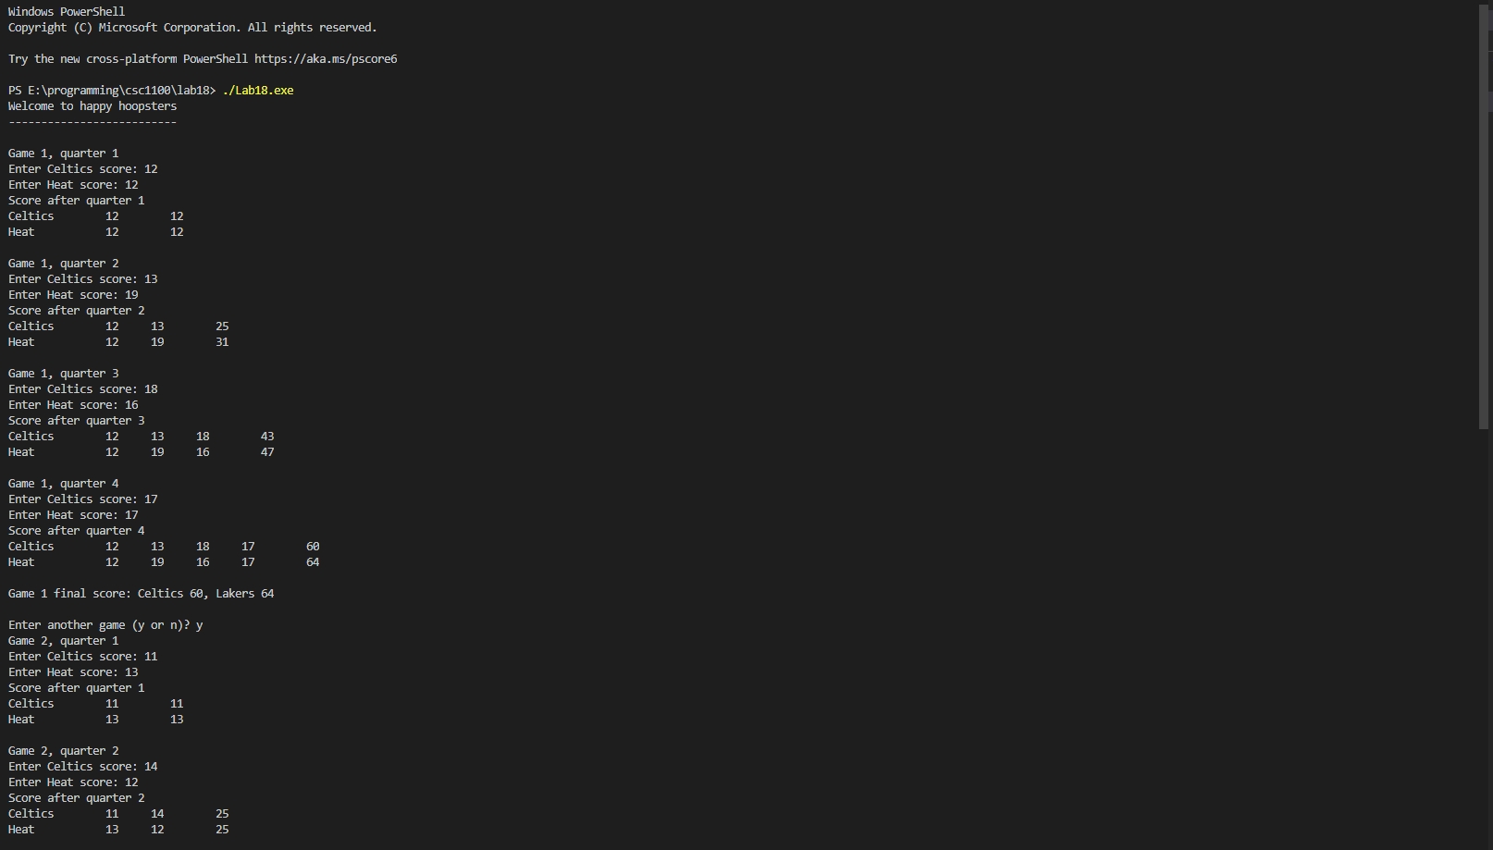

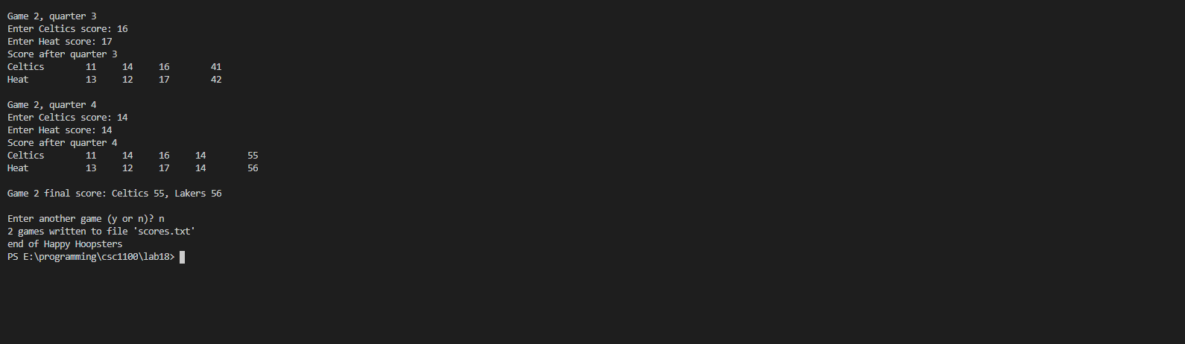

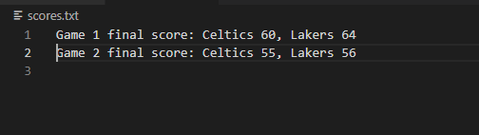

**\* Copying-and-pasting C++ code to a Word document**

**macOS**

1) From within the C++ program, press **command-A** and press **command-C**.

2) From within the Word document, press **command-V**.

**Windows**

1) From within the C++ program, press **CTRL-A** and press **CTRL-C**.

2) From within the Word document, press **CTRL-V**.

**\*\* Copying-and-pasting C++ console application output to a Word document**

**macOS**

1) From the C++ console, press **shift-command-4-space**.

2) From within the Word document, **command-V**.

**Windows**

1) From the C++ console, press **ALT-PrintScreen**.

2) From within the Word document, press **CTRL-V**.